**MFA2 Week 1 homework**

April 2024

Flow-driven homework

Use the file “flow_driven_model_surv.xlsx” in Brightspace.

* Download Domestic Material Consumption data for 1970-2021 of your favorite country from [www.materialflows.net/visualisation-centre/data-visualisations/](http://www.materialflows.net/visualisation-centre/data-visualisations/) . The link is also in Brightspace. If it doesn’t work for some reason, you can use the Kenya data that we downloaded.

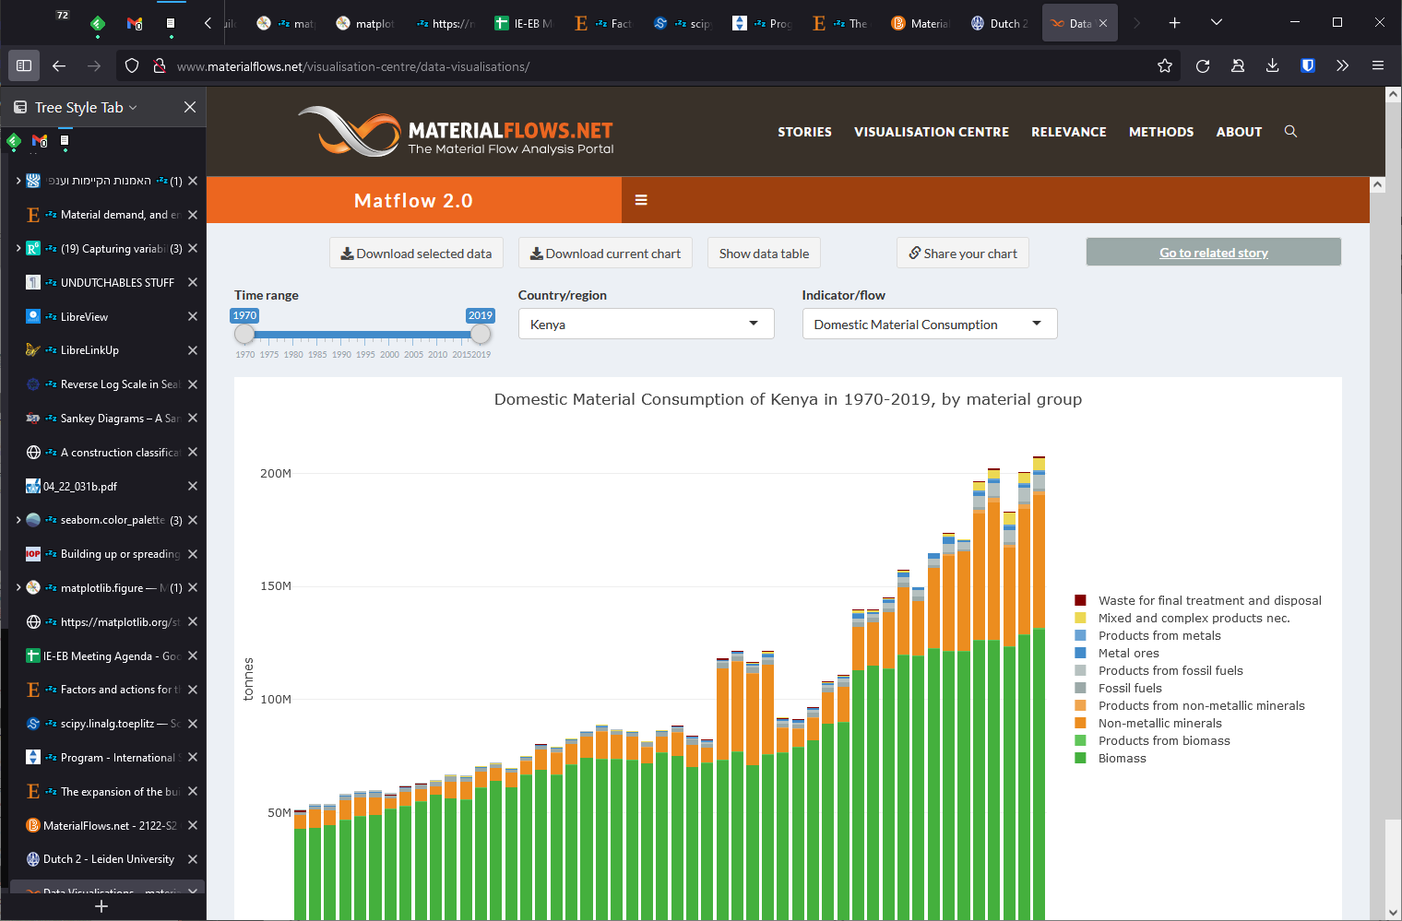

* In Excel, filter to choose the inflow time series of your favorite material.



* Use this data as inflow in Data_Inputs, and make an assumption about its survival   
  curve’s shape and scale: the mean lifespan and standard deviation. The default ones probably don’t make much sense.

1. Describe the trends of the **inflows**, **stocks**, and **outflows** **1970-2021** and **2022-2070**.
2. Compare the **stock composition** in **1980** and in **2019**: how much of it is young cohorts vs. old cohorts, etc.
3. Compare the equations of the flow driven model with the functions in the cells of sheet Cohort_survival_matrix_&Outputs. Show which elements are equivalent to each other.
$$stock\left(y\right)=\sum_{t=y_{0}}^{y}{\left[inflow\left(t\right)×survival\left(y-t\right)\right]}$$

$$NAS\left(y\right)=stock\left(y\right)-stock\left(y-1\right)$$

$$outflow\left(y\right)=inflow\left(y\right)-NAS\left(y\right)$$

4. Can you identify anything problematic about these results?

Stock-driven homework

In preparation for delving into the stock-driven model in class.

Use the stock_driven_model_surv.xlsx file in Brightspace. The input data is a variant of the iron stocks in the USA from Fishman et al. 2014. Note that here in *data_input* we have stock data, and *Cohort_survival_matrix_&Outputs* calculates the inflows.

1. Are there any differences between the sheet Survival_curve_matrix in *stock_driven_model_surv.xlsx* and *flow_driven_model_surv.xlsx*?
2. In sheet Cohort_survival_matrix_&Outputs, describe in human words what the functions in cell F4 do (or any other cell in the table F4:DB104, they’re all the same in principle)
3. In cell F4 and many other cells of F4:DB104, why can’t we just use the same simple function as the equivalent cell F4 from flow_driven_model_surv.xlsx? What happens if we try using the flow driven version here?
4. Column C calculates the inflows. Describe in human words what the function in cell C4 does.
5. What are the differences between columns B and A in the two Excel models?
6. Copy the stocks that you calculated previously in **flow**_driven_model_surv.xlsx into data_input. Does the stock-driven model manage to recreate the inflows from MaterialFlows.net?  
   (hint: there’s one more input variable apart from the stocks that you must compare)